KENDRIYA VIDYALAYA ANDREWS GANJ

2015-2016
COMPUTER SCIENCE (C++)
INVESTIGATORY PROJECT
S.P.PRADHYUMNA

A PROJECT REPORT ON
Railway Ticket Reservation


Submitted By
S.P.PRADHYUMNA
Class: XII A
Under the Guidance of
Mr. ATUL VERMA
PGT (Computer Science)
Department of Computer Science
Kendriya Vidyalaya Andrews Ganj
New Delhi



C E R T I F I C A T E

This is to certify that S.P.PRADHYUMNA
Of Class XII A has prepared the report on the Project entitled “Railway Ticket Reservation”. The report is the result of his efforts & endeavors. The report is found worthy of acceptance as final project report for the subject Computer Science of Class XII. He has prepared the report under my guidance.

(Mr. Atul Verma)
PGT (Computer Science)
Department of Computer Science
Kendriya Vidyalaya Andrews Ganj
New Delhi.

CERTIFICATE

The project report entitled
“Railway Ticket Reservation”,

Submitted by S.P.PRADHYUMNA of Class XII A for the CBSE Senior Secondary Examination class XII of Computer Science at Kendriya Vidyalaya Andrews Ganj New Delhi has been examined.

SIGNATURE OF EXAMINER

D E C L A R A T I O N

I hereby declare that the project work entitled “Railway Ticket Reservation”, submitted to Department of Computer Science, Kendriya Vidyalaya Andrews Ganj New Delhi is prepared by me. All the coding is result of my personal efforts.

S.P.PRADHYUMNA
Class XII A

A C K N O W L E D G E M E N T

I would like to express a deep sense of thanks & gratitude to my project guide Mr. Atul Verma Sir for guiding me immensely through the course of the project. He always evinced keen interest in my work. His constructive advice & constant motivation have been responsible for the successful completion of this project.

My sincere thanks go to Shrimati. Rashmi Our principal madam, for his co-ordination in extending every possible support for the completion of this project.

I also thanks to my parents for their motivation & support. I must thanks to my classmates for their timely help & support for compilation of this project.

Last but not the least; I would like to thank all those who had helped directly or indirectly towards the completion of this project.

S.P.PRADHYUMNA
Class: XIIA

CONTENTS  1. | HEADER FILES USED. . . . . . . . . . . . . . . . .
2. | FILES GENERATED. . . . . . . . . . . . . . . . . . .
3. | WORKING DESCRIPTION. . . . . . . . . . . . .
4. | CODING . . . . . . . . . .. . . . . . . . . . . . . . . . .
5. | OUTPUT SCREENS. . . . . . . . . . . . . . . . . . .
6. | CONCLUSION. . . . . . . . . . . . . . . . . . . . . . . . . .
7. | BIBLIOGRAPHY. . . . . . . . . . . . . . . . . . . . . . . . .
HEADER FILES USED

1. FSTREAM.H – for file handling, cin and cout
2. PROCESS.H – for exit () function
3. CONIO.H – for clrscr () and getch () functions
4. STDIO.H – for standard I/O operations
5. STRING.H – for string handling
6. MATH.H–for doing mathematical operations

FILES GENERATED

DATA FILES
TRAIN.DAT

PROGRAM FILE
RAILWAY TICKET RESERVATION.CPP

OBJECT FILE
TRAIN.OBJ

EXECUTION FILE
TRAIN.EXE

WORKING DESCRIPTION

This program is designed to keep the friend’s record.
This program consists of FIVE options as follows

1. TO ADD NEW RAILWAY STATION
2. TO BOOK TICKET
3. TO CHANGE PER KM RATES
4. TO MODIFY DATABASE OF TRAIN
5. TO EXIT

CODING

//Indian Railways - Ticket Reservation
//Submitted By S.P.PRADHYUMNA
#include<fstream.h>
#include<conio.h>
#include<stdio.h>
#include<math.h>
#include<string.h>
#include<process.h>
char from[30],to[30];
void detail()
{
cout<<"From"<<endl;
gets(to);
cout<<"To"<<endl;
gets(from);
}
class railways
{
char station[30];
unsigned int distance;
float fare;
public:
void ad_data()
{
cout<<"Enter Railway Station name"<<endl;
gets(station);
cout<<"enter its distance from Jammu Tawi"<<endl;
cin>>distance;
}
void amount(int a,int b,int c)
{
cout<<"total distance="<<fabs((a-b))<<"\n charges per/km="<<c;
fare=fabs((a-b))*c;
cout<<"\nticket cost ="<<fare;
}
unsigned int dist()
{
return distance;
}
char* station_v()
{
return station ;
}
void modify()
{
cout<<"\nEnter new railway station\n";
gets(station);
cout<<"\nenter its distance from Jammu Tawi\n";
cin>>distance;
}
}tr;
void main()
{
clrscr();
unsigned int per_km=5,choice, d1=0,d2=0,i;
char station_searched[30];
while(1)
{
clrscr();
cout<<"\n\t\t\tWELCOME TO INDIAN RAILWAYS\n";
for(i=0;i<80;i++)
{
cout<<"-";
}
cout<<"Enter your choice \n\t1:->Add new railway station\n\t2:->Book ticket"<<endl;
cout<<"\t3:->Change per km rates\n\t4:->modify database of train\n\t5:->exit\n";
for(i=0;i<80;i++)
{
cout<<"-";
}
cin>>choice;
while(choice==1)
{
ofstream of1("train.dat",ios::binary|ios::app);
tr.ad_data();
of1.write((char*)&tr,sizeof(tr));
of1.close();
break;
}
while(choice==2)
{
ifstream of1("train.dat",ios::binary);
detail();
while(of1)
{
of1.read((char*)&tr,sizeof(tr));
if(0==strcmp(from,tr.station_v()))
{
d1=tr.dist();
}
if(0==strcmp(to,tr.station_v()))
{
d2=tr.dist();
}
if(d1 && d2)
{
tr.amount(d1,d2,per_km);
getch();
break;
}
if(of1.eof())
{
cout<<"\nstations not found check your spelling\n";
getch();
}
}
of1.close();
break;
}
if(choice==3)
{
cout<<"Enter new per km rates";
cin>>per_km;
}
if(choice==4)
{
cout<<"enter the railway station to be changed";
gets(station_searched);
ifstream f1("train.dat",ios::binary);
while(f1 )
{
f1.read((char*)&tr,sizeof(tr));
long pos=f1.tellg();
if(0==strcmp(station_searched,tr.station_v()))
{
f1.seekg((-1*sizeof(tr),ios::cur));
tr.modify();
f1.close();
ofstream f1("train.dat",ios::app);
f1.seekp(pos,ios::beg);
f1.write((char*)&tr,sizeof(tr));
cout<<"record modified";
f1.close();
break;
}
else if(f1.eof())
{
cout<<"\nStation not found\n";
getch();
}
}
}
if(choice==5)
{
cout<<"\nTHANK YOU FOR USING INDIAN RAILWAYS ";
getch();
exit(0);
}
if(choice!=1&&choice!=2&&choice!=3&&choice!=4&&choice!=5)
{
cout<<"entered wrong choice PROGRAM IS ABORTING!!!!!!";
getch();
exit(0);
}
}
getch();
}

OUTPUT

1. WELCOME SCREEN
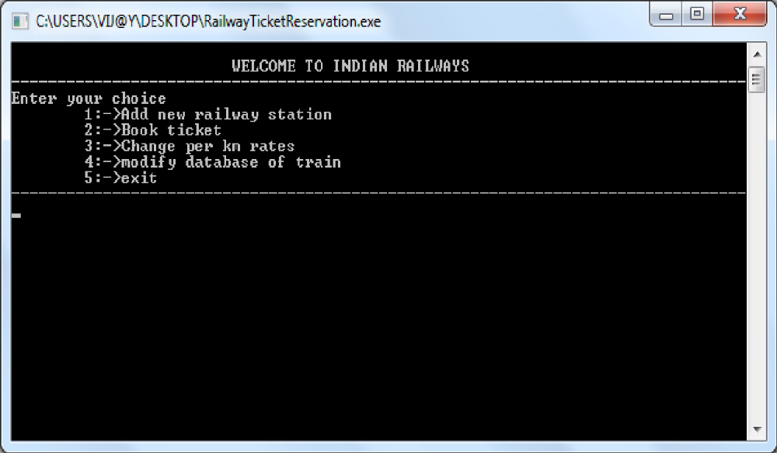
2. ADD NEW RAILWAY STATION
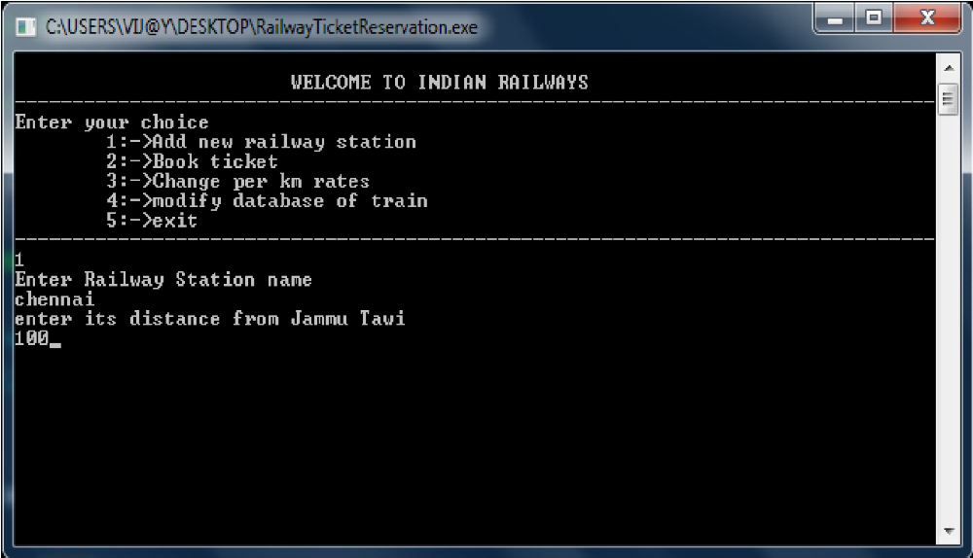

3. TO BOOK TICKET
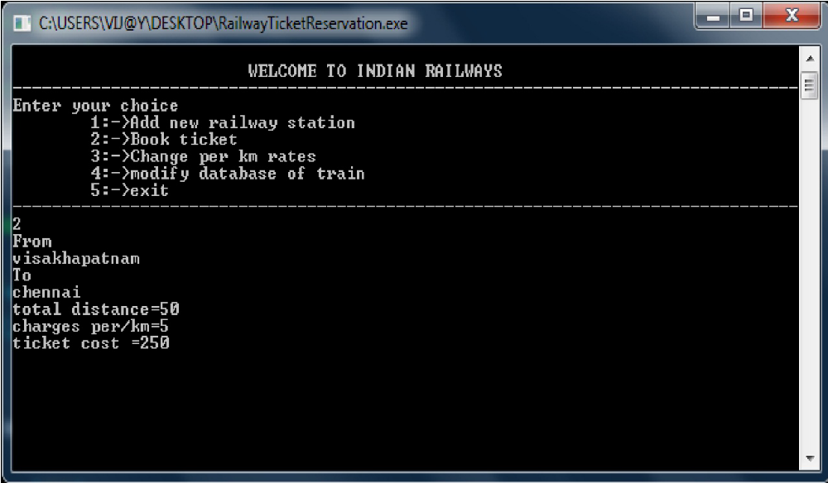

4. TO CHANGE PER KM RATES
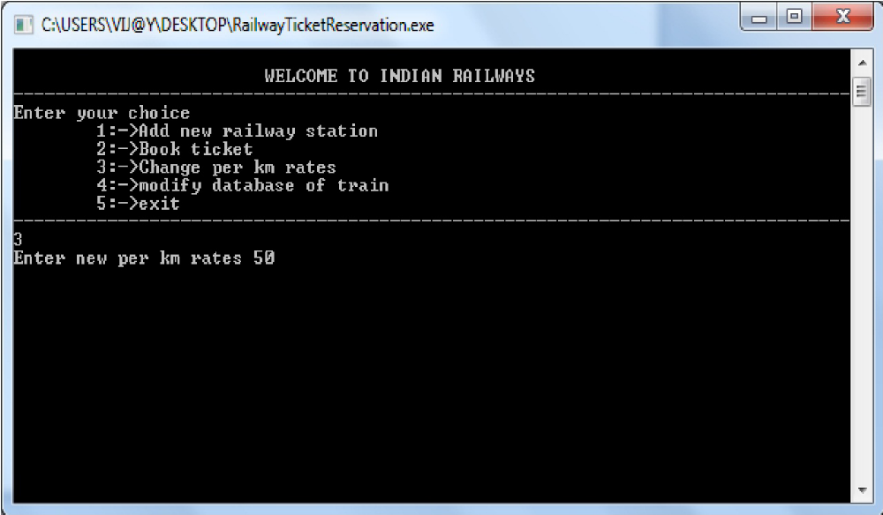

5. TO MODIFY DATABASE OF TRAIN
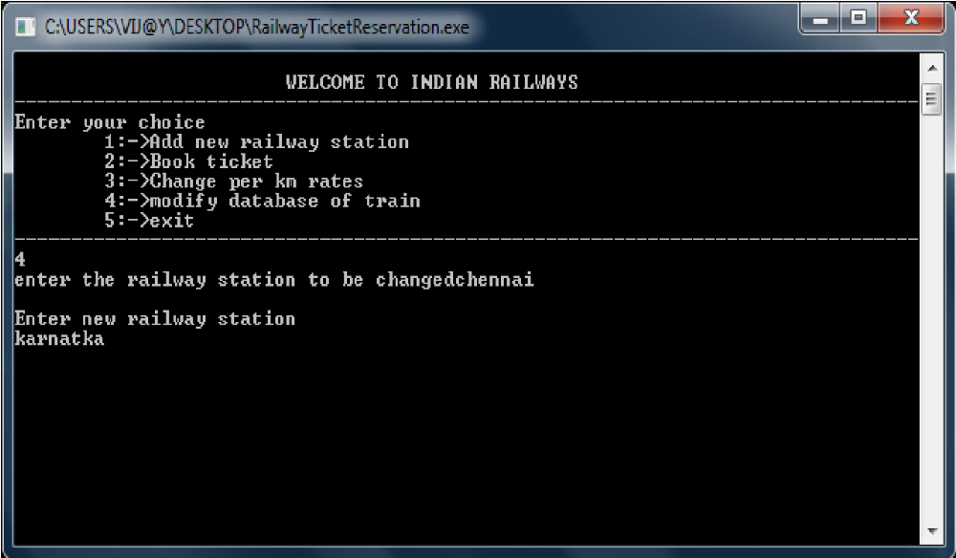
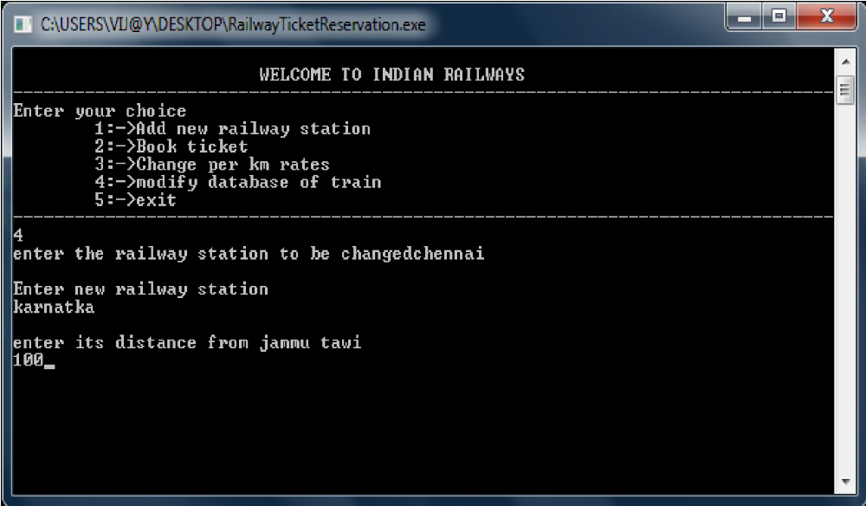

6. TO EXIT
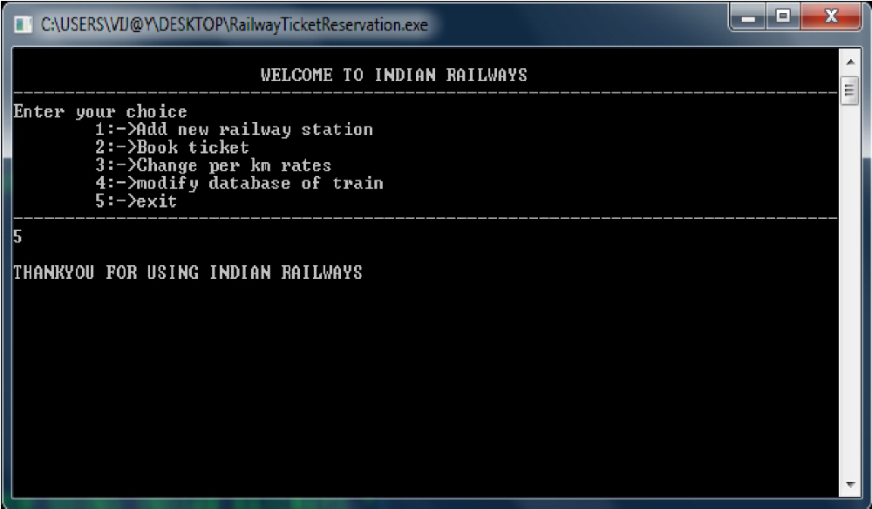

BIBLIOGRAPHY

1 The C++ Programming Language

2 Programming in C++

3 Computer Science with C++ by Sumita Arora

4 Object Oriented Programming by Robert Lafore

5 www.bOtskOOL.com

